**Condensation polymerisation**

Polymers are synthesised by reacting monomer molecules together to create covalent bonds between them, which links all the monomers together to make the polymer. The functional groups in the monomer and the conditions of the reaction determine the type of polymer made. The two basic types of polymerisation reactions are addition polymerisation and condensation polymerisation.

Addition polymerisation requires that the monomer have a double bond. In addition reactions the double bond breaks allowing the carbons on either end of the double bond to form new single bonds linking the monomers together.

However, if the monomer molecules have a functional group at each end, the functional group can undergo a condensation reaction with a functional group on another molecule to form a condensation polymer. Condensation polymers are formed when two monomer molecules join together to eliminate a small molecule (often water). The process is called condensation polymerisation. Condensation reactions occur between monomers when the monomers have two functional groups which can react together to form a single functional group. This means that condensation reactions generally involve reactions between:

* a carboxylic acid and an amine functional group (producing amide functional groups. These polymers are referred to as polyamides – nylon, Kevlar; or polypeptides – proteins)
* a carboxylic acid and a hydroxyl functional group (producing ester functional groups. These polymers are called polyesters)
* have two hydroxyl functional groups (producing glyosidic bonds in polysaccharides, or carbohydrates).

Polyesters and polyamides (nylons) are examples of synthetic condensation polymers whereas polypeptides (proteins) and polysaccharides (cellulose and starch) are examples of natural condensation polymers.

(i) Formation of proteins (polypeptides) via condensation reactions.

If a monomer molecule contains both a carboxylic acid and an amine group, these functional groups can react to make a polymer. This reaction creates an amide group between the monomers to make the polymer.

Amino acids are molecules which contain an amine and a carboxylic acid group. Amino acids combine together to make protein polymers via this type of condensation reaction. All Amino acids share a very similar structure around these two functional groups, and vary only in the structure of the central substituent group (R).The general structure of an amino acid is shown on the left, and six common amino acids are shown below. Glycine is the simplest of the Amino Acids as it has no R group.

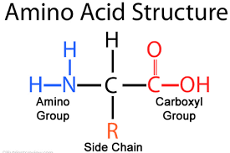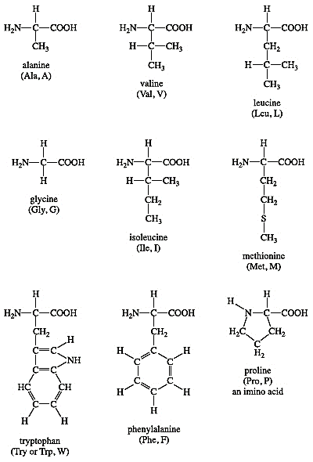

The condensation reaction joins the amino acids by combining the amine and carboxylic acid groups on each amino acid, and therefore eliminating water to make an amide functional group linking the amino acids together. The resultant structure is called a polypeptide. Proteins are polypeptides made naturally by organisms from the amino acids they consume.

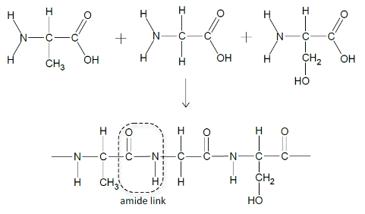

+ 2 H2O

(ii) Formation of Polyesters via condensation reactions.

If a monomer molecule contains both a carboxylic acid and a hydroxyl functional group, these functional groups can react to produce a polyester – a polymer with ester linkages. The reaction between the carboxylic acid and the hydroxyl group eliminates water and produces an ester functional group which bonds the monomers together.

The condensation reaction between the carboxylic acid and the hydroxyl groups eliminates water and produces an ester link between two R groups

Polyesters can be produced by:

1. A single monomer that has a hydroxyl (-OH) functional group at one end and a carboxyl (-COOH) functional group at the other. This polyester made of a single repeating unit

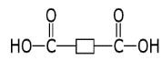

**R**



**R**

+



**R**

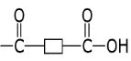

**R**

+ H2O

1. Two different monomers - one with hydroxyl groups at each end (a diol) and one monomer with carboxyl functional groups at each end (a dicarboxylic acid). These polyesters have two repeating units.

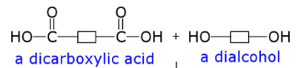

**R**

**Ri**

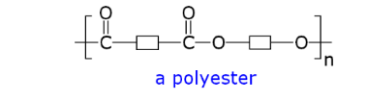

**R**

**Ri**

+ H2O



1. An example of the use of a single monomer is the condensation polymerisation of lactic acid, CH3CH(OH)COOH to produce polylactic acid (PLA) and water. Polylactic acid is used in some medical applications as it naturally breaks down over time. This offers a significant advantage in application such as internal surgical sutures. Lactic acid is a single monomer with both Hydroxyl and Carboxylic acid functional groups – shown on the right

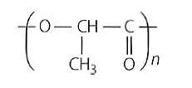

Polylactic acid

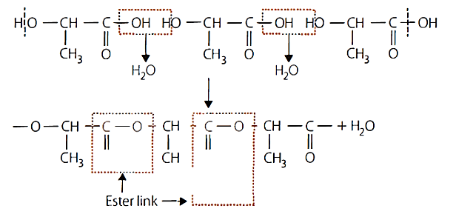

The condensation polymerisation reaction of Lactic acid



2

+ 2 H2O

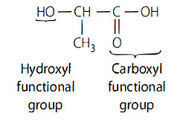

Lactic acid

2. An example of the use of two monomers to produce a polyester is the condensation polymerisation between the diol molecule ethan-1,2-diol, and the dicarboxylic acid molecule Benzene -1,4-dicarboxylic acid

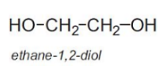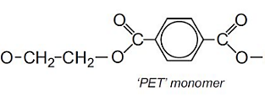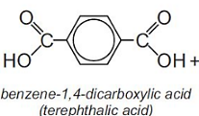

+ *n* H2O

*n*

(ii) Formation of Polysaccharides (carbohydrates) via condensation reactions.

If monomer molecules contains two hydroxyl functional group, these functional groups can react together to an ether linkage between the monomers. This reaction commonly joins monosaccharides (simple sugars or carbohydrates) to create larger chains of saccharides, called polysaccharides or complex sugars. In polysaccharides the bond created between the monomers (monosaccharides) is called a glycosidic link. The glycosidic link shown on the right is a 1-4 glycosidic link in the disaccharide maltose. These are very common, although glycosidic links can form between atoms in other positions.

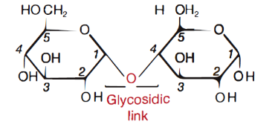

6

6

The steps below show the formation of sucrose (a disacharide) from the monomers of glucose and fructose. In the formation of large polysacharides such as celluluse and glycogen, this process of forming glycosidic links occurs many times.

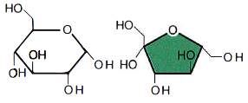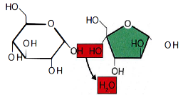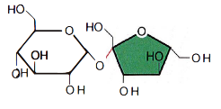

The two monomers come close enough together for the hydroxyl groups to react.

Water is eliminated.

Glycosidic link forms

+ H2O

**Questions**

1. What is a condensation reaction?
2. What two functional groups are found in every amino acid?
3. Draw the generic (generalised) structure for an amino acid?
4. Draw the structural formula for the products formed in the condensation reaction between a glycine molecule and a valine molecule?
5. 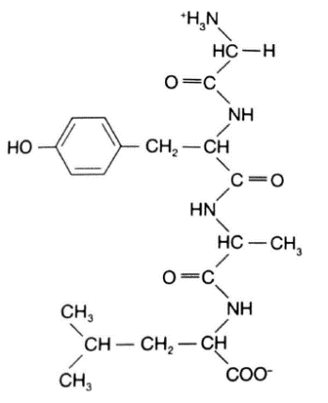In the poly peptide below,

(i) Identify (by circling) the peptide linkage,

(ii) Name the amino acids used to produce this polypeptide, and

(iii) Identify how many molecules are eliminated in the reaction to produce this polypeptide.

1. Do Q8, page 148 of your text.
2. Draw the structural formula for the polymer unit (using the [ ]n notation seen in the notes) produced from the reaction between 1,2-ethandiol and hexanedioic acid. Note the use of the e when dioic acid groups are present (ie. hexanoic acid versus hexanedioic acid).
3. What functional group is the bond between the monomer units in your answer to Q 7.?
4. Another polyester is shown below with several repeated units of the monomer.

-OOCC3H4COOCH2CH2CH2OOCC3H4COO CH2CH2CH2OOCC3H4COO CH2CH2CH2-

(i) Draw the structural formula for this polymer in the [ ]n form.

(i) Circle the ester linkages in the above polymer structure.

(ii) Write the molecular formulas (CxHyOz) and structural formulas of the two monomers used to construct it.

1. Which type of condensation polymer is formed when the following two chemicals react together?
2. 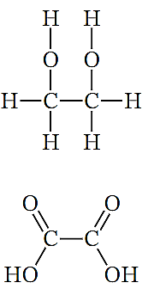Polynitrile
3. Polyester
4. Polyethene
5. Polyvinyl
6. Polyamide
7. 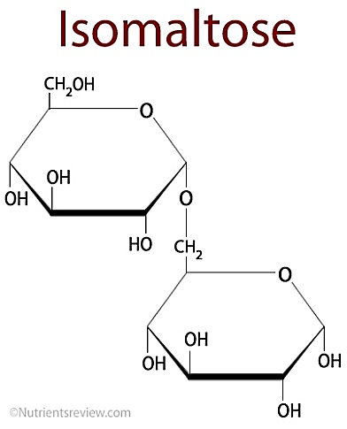The molecule shown on the right is isomaltose.

(i) What is the name of the bond joining these two monomers together?

(ii) What is the name of the monomer in this molecule?

(ii) What are the numbers of the carbon atoms being joined by the link?